Group 29

user manual

Table of Contents

Introduction 2

Landing page 3

Login page 4

Register page 5

Earn points while learning 6

Top 3 courses 7

Dashboard 8

Enrolling onto additional courses 10

Posting Reviews 12

User Profile 13

Upload Profile Picture 13

Friends page 14

Add Friends 15

Leaderboard page 16

Ranking/ Level Page 17

Admin Profile 18

Admin - Deleting Reviews 20

Admin Analytics 21

Common errors and solutions 22

Incorrect email or password 22

Email already in use 22

Password does not match and the length is less than 8 characters 23

Invalid token 24

# Introduction

Welcome to IBM SkillsBuild, a gamified learning website designed to motivate you to unlock new skills in a fun and engaging way. This manual provides instructions on how to easily navigate and use our website.

# Landing page

<http://localhost:3000/>

As you enter the IBM SkillsBuild website, the landing page provides a brief introduction to what we offer. New users can click the “Register” button, leading to the register page where they can create an account and begin their learning journey. Existing users should click the “Login” button to reach the login page. After entering your login details, you will be able to pick up your learning right where you left off.

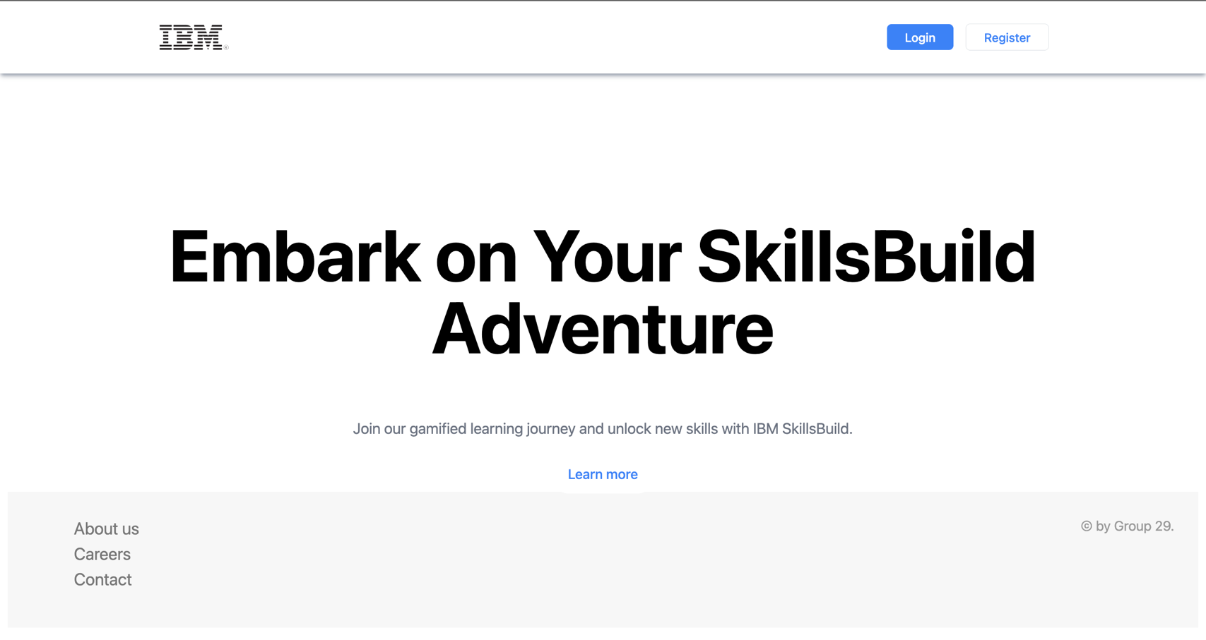

New user’s can click this button to create their account

Existing user’s can click this button to log in

## Login page

<http://localhost:3000/login/>

As you navigate to the IBM SkillsBuild website, you'll encounter the login page, which serves as your gateway to our platform. New users who haven't yet created an account can easily do so by clicking on the "No account? Sign up" button, directing them to the registration page where they can swiftly set up their accounts and embark on their learning journey. For existing users, simply click the "Login" button to access your account. Once logged in, you'll seamlessly resume your learning from where you last left off, ensuring a smooth and uninterrupted experience.

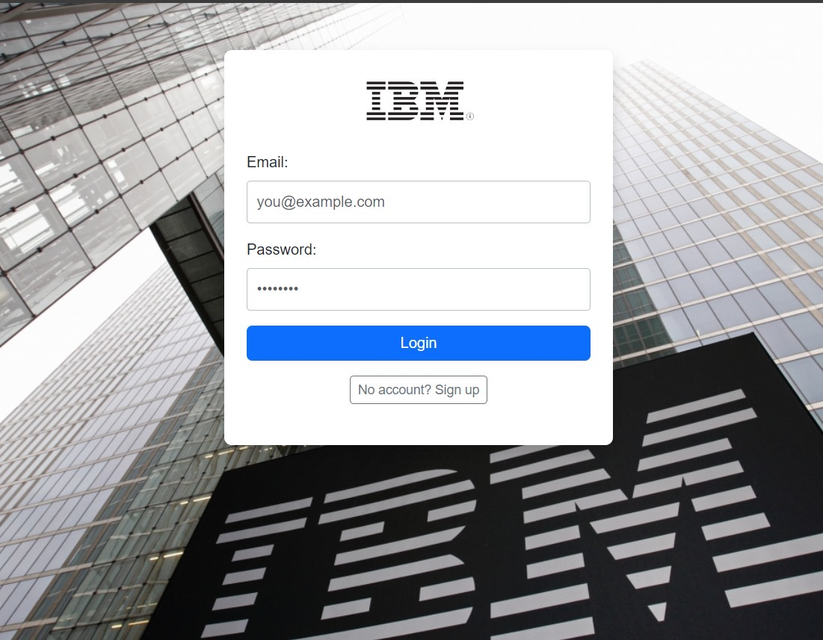

Click here to login.

Enter Email and password used during registration.

## Register page

<http://localhost:3000/register/>

Upon visiting the IBM SkillsBuild registration page, newcomers are greeted with a clean and minimalistic form to sign up for their learning adventure. It requires essential information such as the user's name, email, and a password, which they need to confirm for security purposes. Once the details are filled out, clicking the blue "Register" button will set up the new account. Those who already have an account can navigate to the login page through the provided link to continue their educational journey with IBM SkillsBuild.

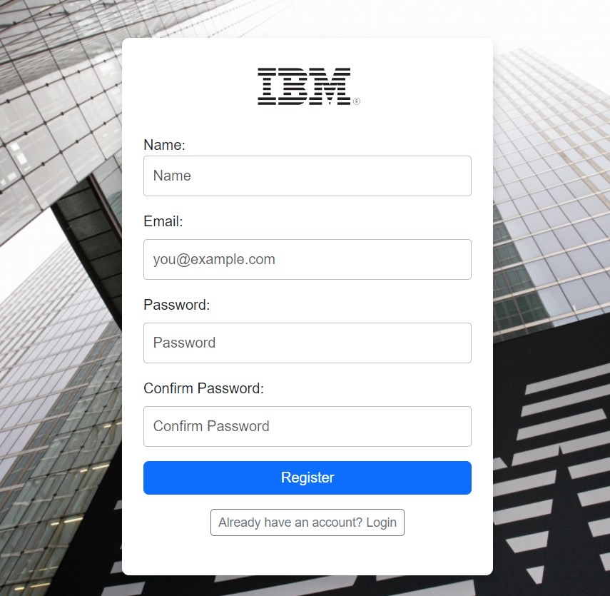

Click to register yourself.

Enter you the email and password you want to register with.

Enter your full name.

# Earn points while learning

<http://localhost:3000/dashboard>

As you complete courses and make your way through learning modules, you'll earn points as a fun bonus. These points are a way to track your achievements and compete with other students.

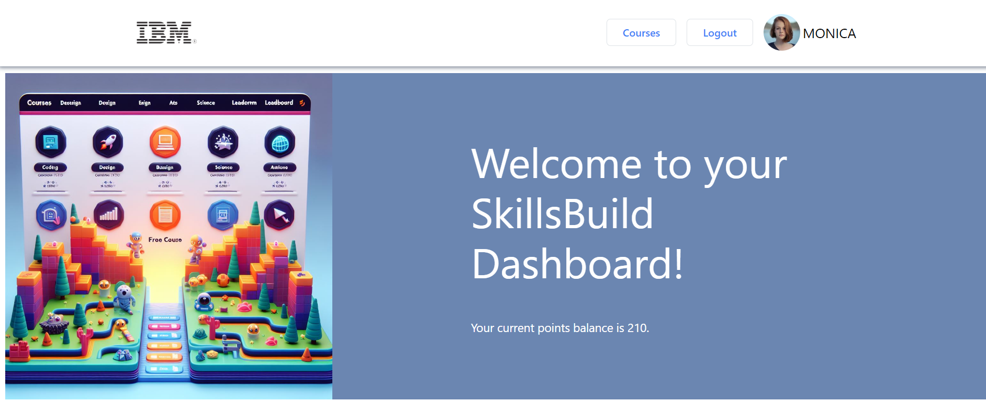

You can earn points by completing courses.

Remember to refresh the page to view your updated points.

# Top 3 courses

<http://localhost:3000/courses>

For students exploring their options or unsure about which courses to take, our 'Top 3 Courses' section showcases the courses other students have enjoyed and found valuable, providing insights to help you make an informed decision about your learning path.

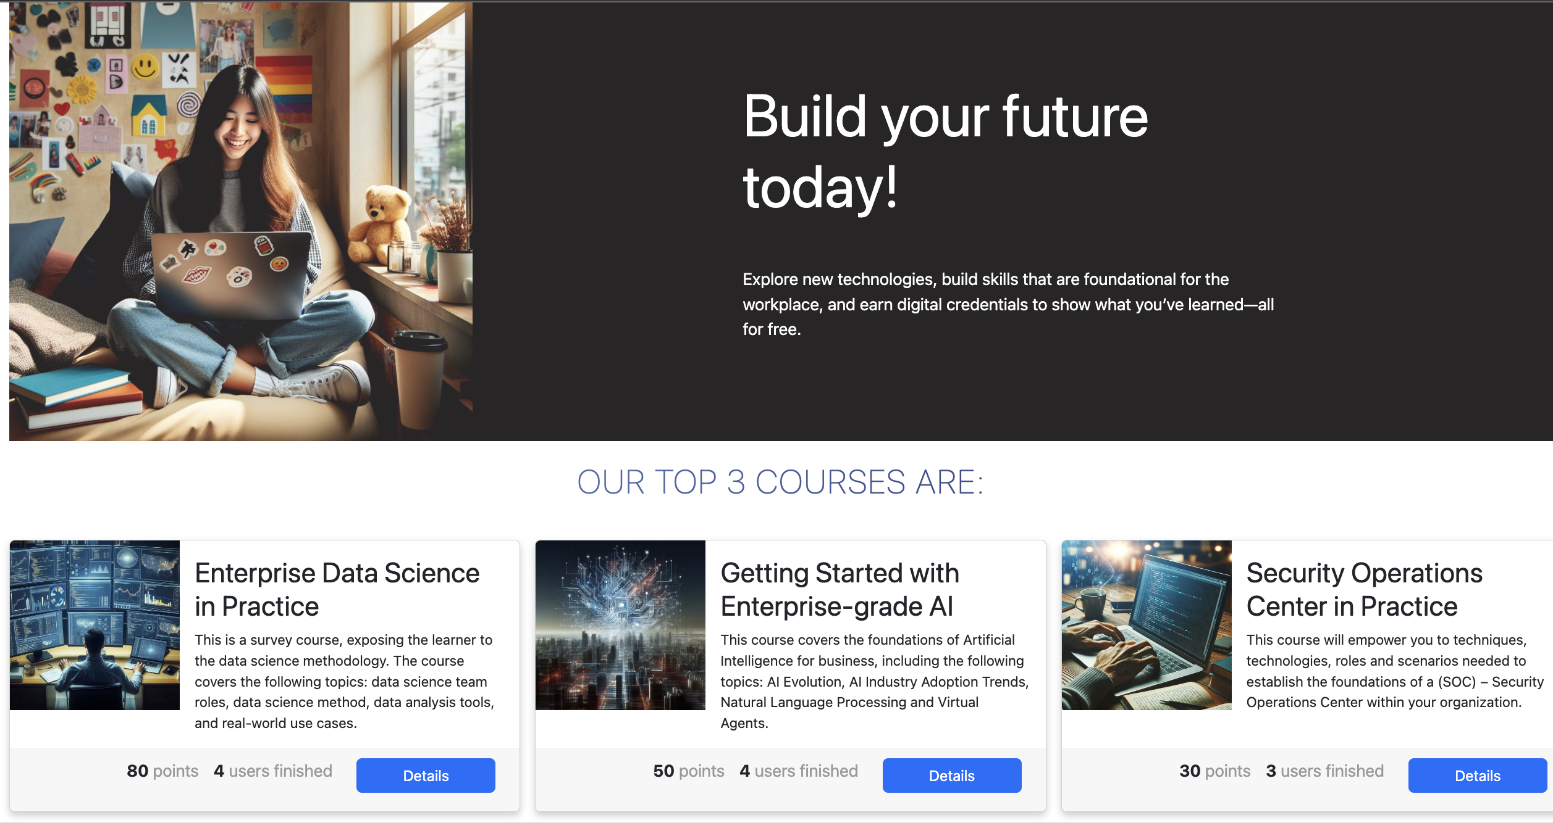

This section of the courses page shows you the top 3 courses.

# Dashboard

<http://localhost:3000/dashboard>

After logging in, you will be presented with an overview of the courses you are currently enrolled on. This allows you to quickly track your progress and stay updated on your ongoing learning activities.

Your current courses on this page include a brief summary, the option to start a course you have enrolled on, continue a course if it has not yet been completed and to review a course if it is complete.

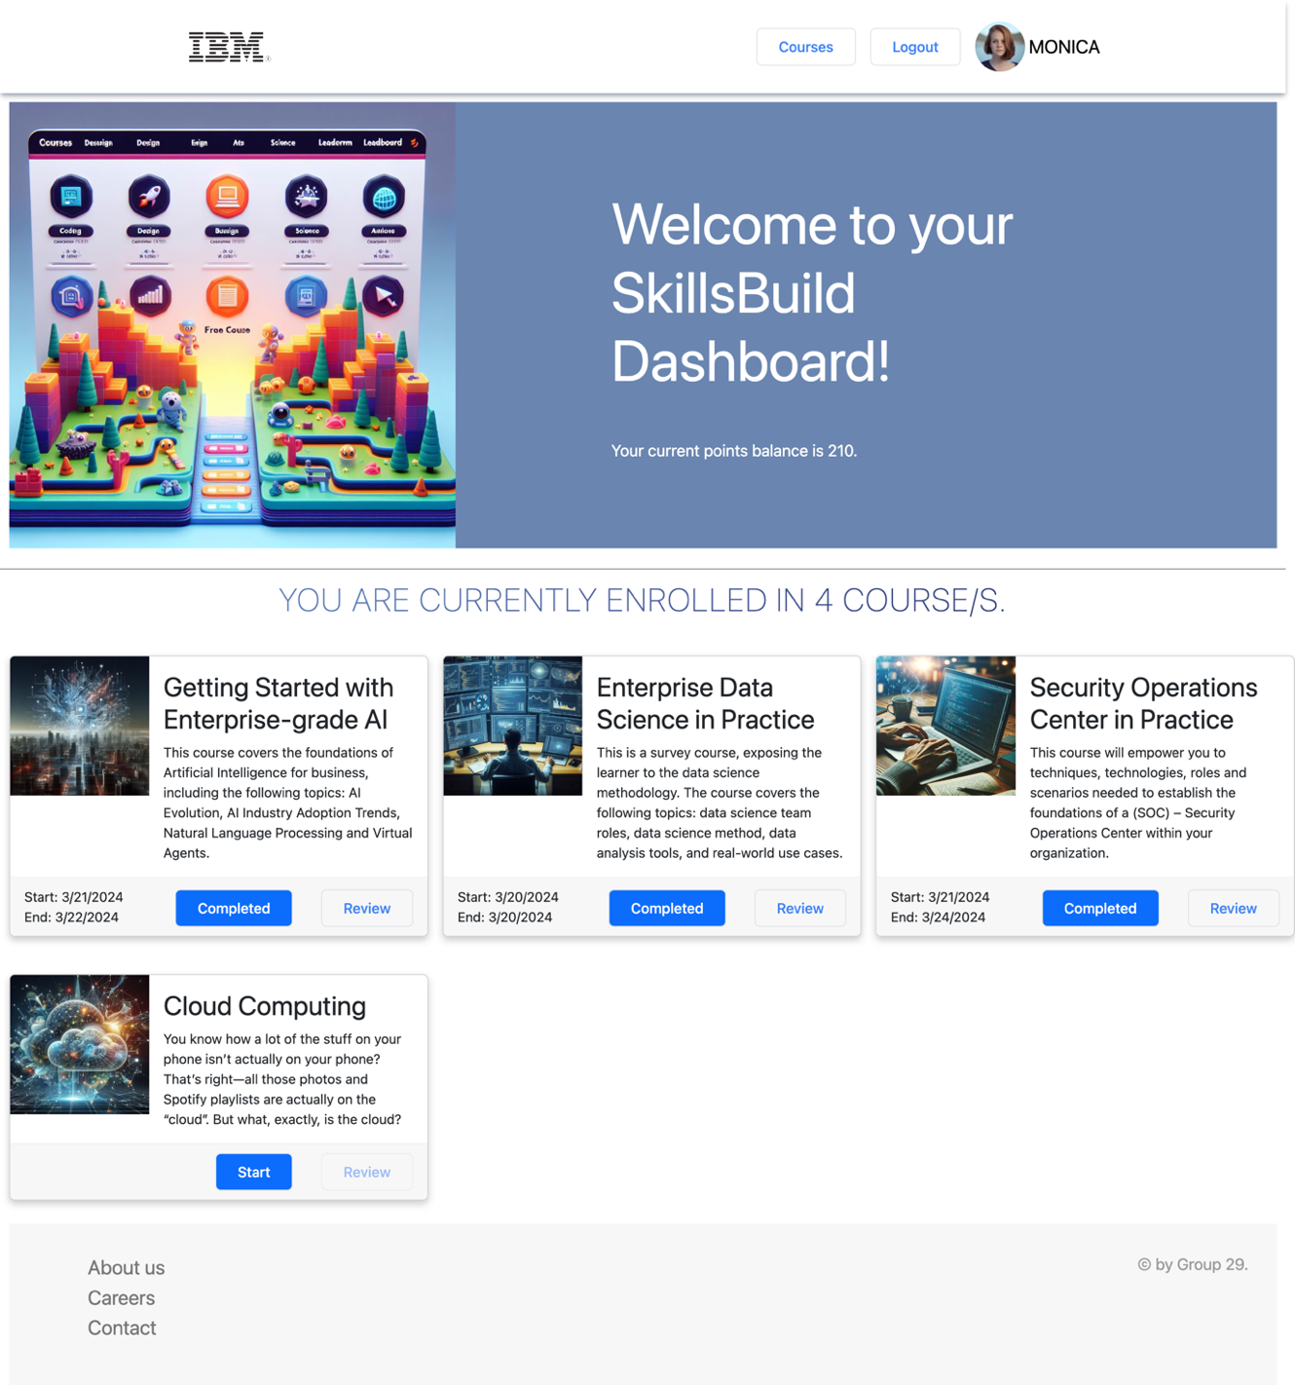

Click here to start a course that you have enrolled onto.

Click here to review a course once you have completed it.

Click here to discover new courses.

Click here to securely log out of your account.

Clicking on the “Start” button will open the course page as shown below.

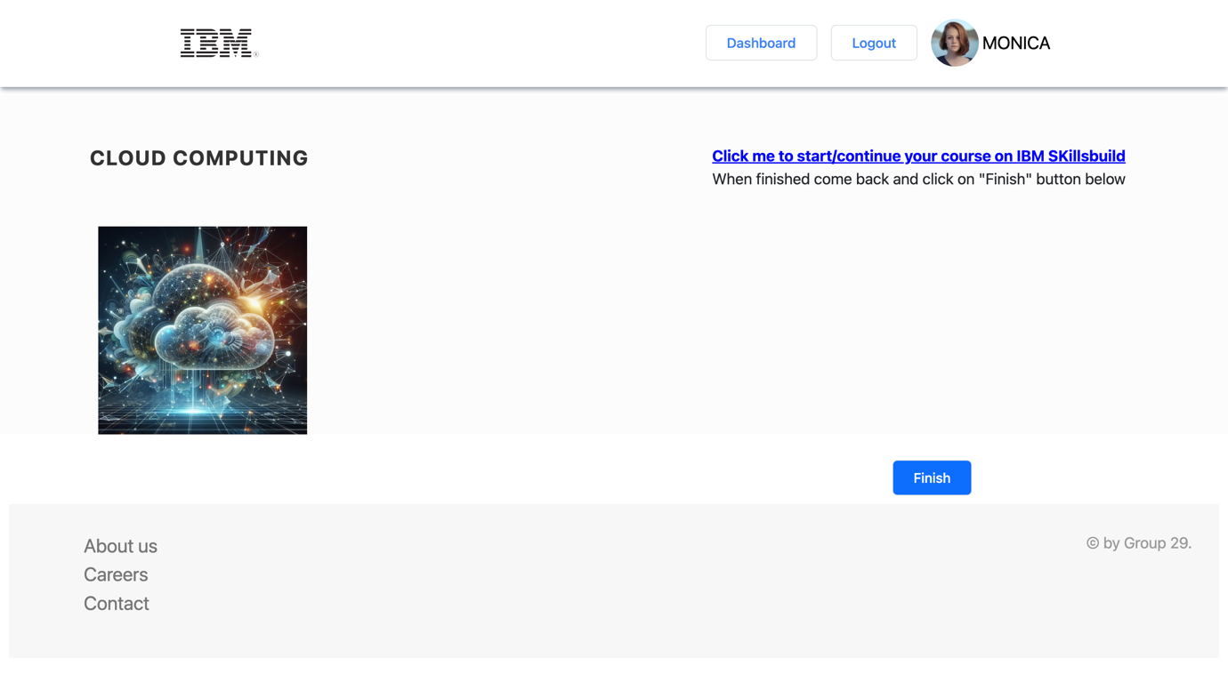

Click here to mark the course as complete.

Once you have completed a course, mark the course as finished with the “Finish” button. The course will then appear as “Completed” on your dashboard. The course will not be available to you anymore.

If you wish to complete it later, you can exit the page and the course will appear on your dashboard with the option to continue it instead.

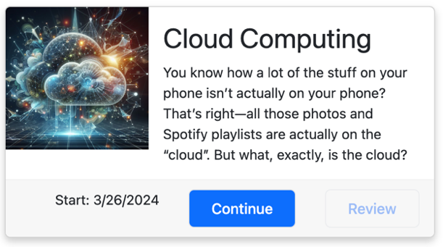

Click here to continue a course you have already started.

## Enrolling onto additional courses

<http://localhost:3000/courses>

To find additional courses, click on “Courses” option of the navigation as shown below.

You will be directed to the Courses page, where you can discover a wide range of available courses. This page lists the top 3 courses and other available courses, each with a brief summary.

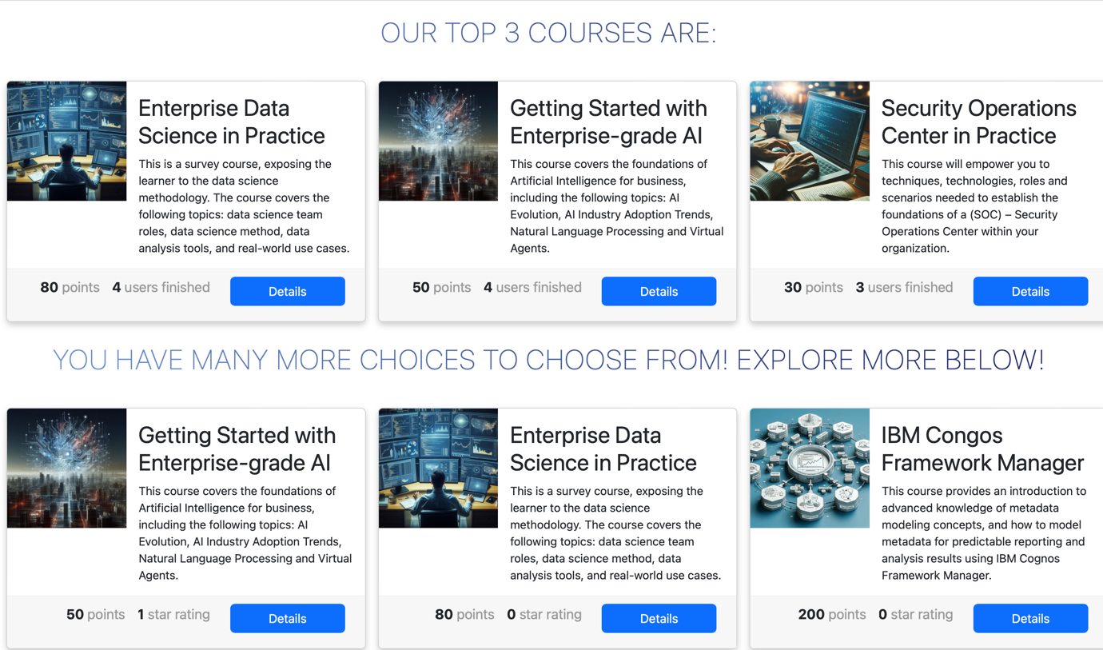

Click here to open the course page and enrol.

To find out more about a course that interests you, click on the “Details” button to open the course’s page. Here you will find further details about the course. a summary, duration, location, points for completion and difficulty level.

Additionally, you will find user reviews on the course page to help you make an informed decision about your course selection.

To enrol onto the course, click the “Enrol now” option as shown below. This course will then be available to access on your dashboard.

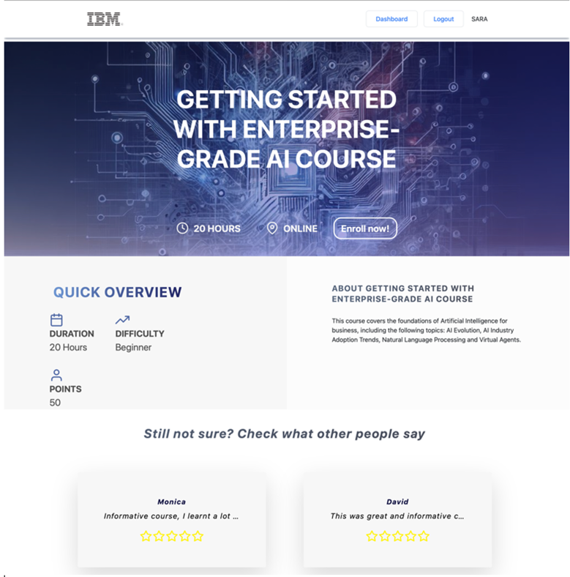

Click here to enrol. The course will then be available on your dashboard.

# Posting Reviews

<http://localhost:3000/review/getting-started-with-ai>

Once you have completed a course, you can post a review.

Navigate to your dashboard and locate the “Review” option of a course.

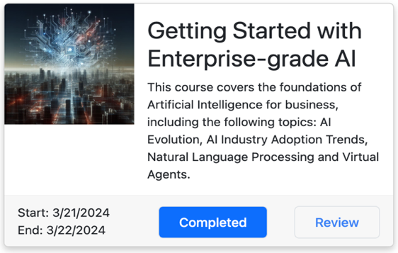

Click here to review a course that you have completed.

This will give direct you to a form to fill in to review the course, where you can enter a star rating out of 5 and a review. Click the “Submit” button to post the review. This will make your review available to other users.

(Note: Only one review can be posted per user to prevent spam.)

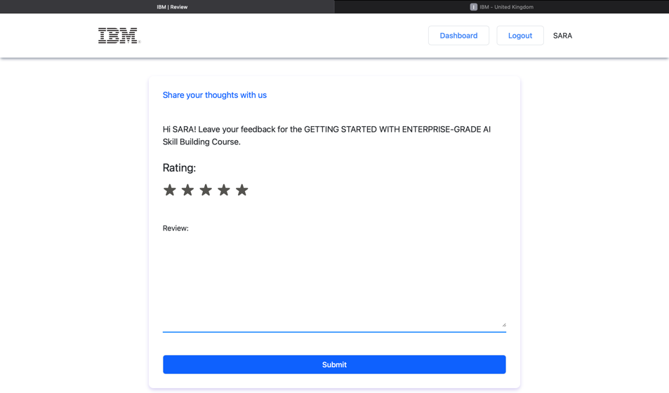

Click the stars to give a rating.

Click here to submit your review.

Type your review here.

# User Profile

<http://localhost:3000/account>

To change your details or view other settings, you can click on your profile to explore more options such as updating picture, add friend, leaderboard, check you level and check your friends list.

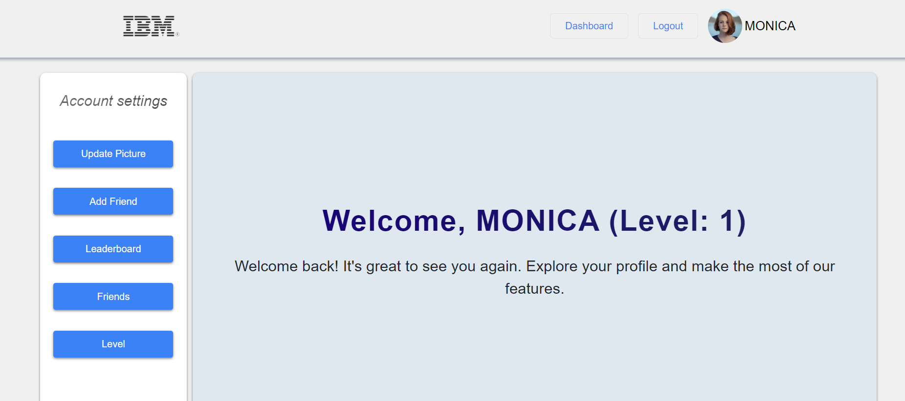

Click here to view your profile.

## Upload Profile Picture

<http://localhost:3000/account/uploadPhoto>

If you want to upload/update your profile picture click on “Upload Photo from the side navigation bar and click on the “Choose new photo” and then click on “Upload picture button”.

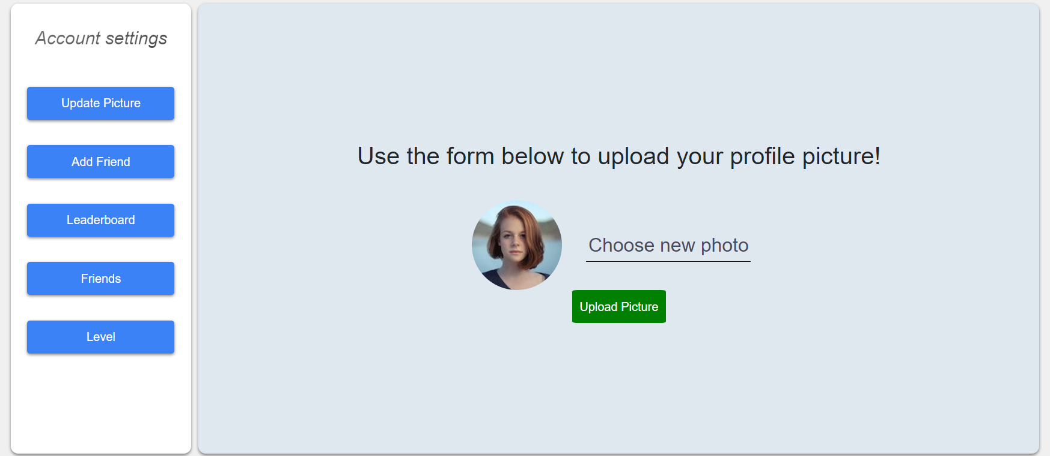

## Friends page

<http://localhost:3000/account/friends>

On the 'Friends' page, you can view all the friends you've added. It's a place where you can see a list of your friends and see how far they've come. This way you can keep up with their successes and stay inspired by their progress.

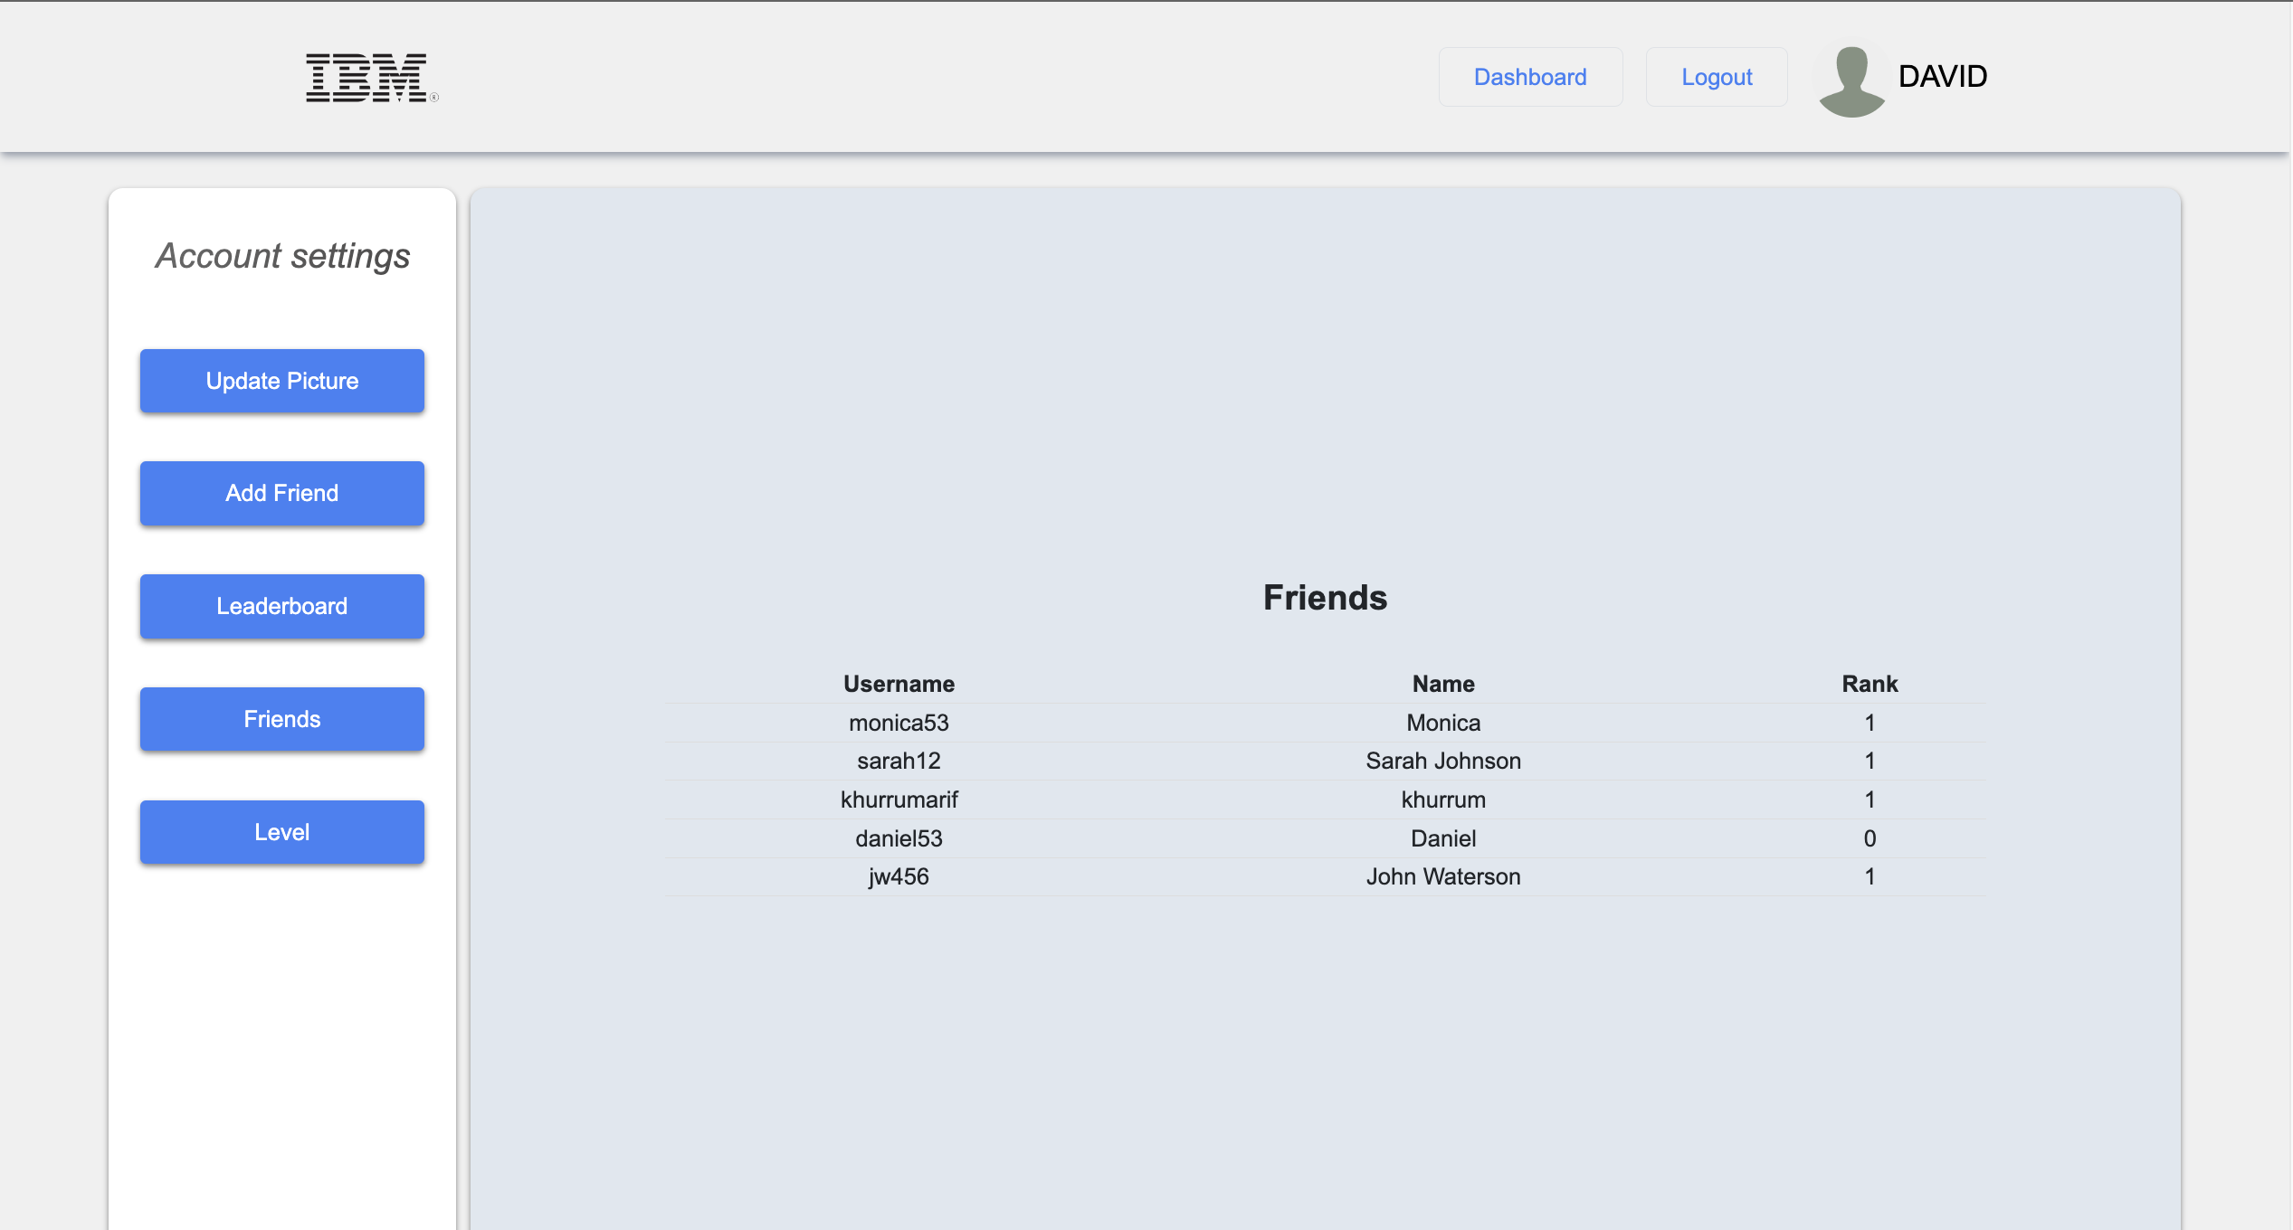

Click the Friends button to view the friends page

### Add Friends

<http://localhost:3000/account/searchFriend>

The 'Add Friend' feature lets you connect with other users. Simply search for them by their username, and you'll see their name and rank. Once you click the 'Add Friend' button you'll be able to see them in your 'Friends' list. This allows you to follow their progress and see their rank, which can be a fun way to encourage competition.

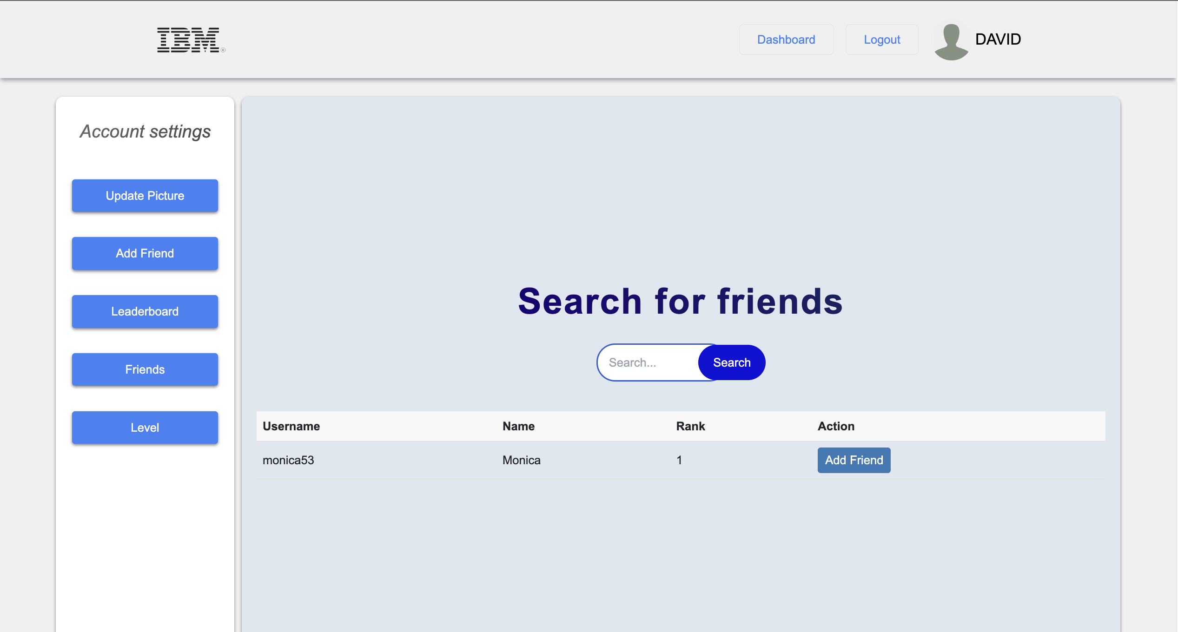

Click Add Friend button to add them to your friends list

Search your friends username here

Click the Add Friends button to view the Add Friends page

## Leaderboard page

<http://localhost:3000/account/friendsLeaderboard>

On the 'Leaderboard' page, you'll find a ranking of users based on points they've earned. You can see who's at the top and check out where you and your friends stand. This will add a little friendly competition to your learning experience.

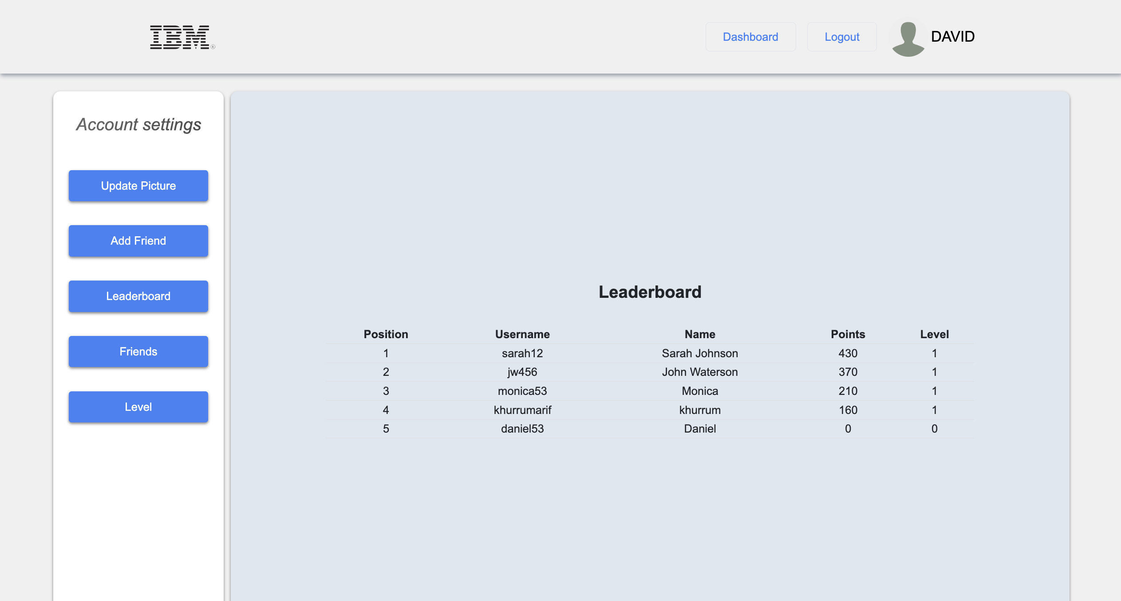

Click the Leaderboard button to view the Leaderboard page

## Ranking/ Level Page

<http://localhost:3000/account/level>

To view your current level or rank click on “Level” button inside menu bar. On this page you will be able to view your name, your current points balance and the levels you have unlocked. The unlocked level will be colored, and the locked will be grey color.

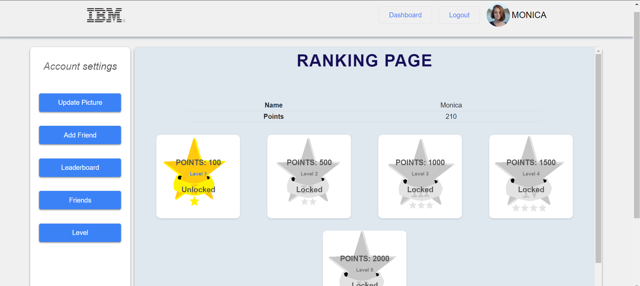

Unlocked level.

Your details displayed here

Click the Level button to view the level/ranking page

Locked levels.

# Admin Profile

<http://localhost:3000/admin-dashboard>

After logging in as an admin, your dashboard will appear first. From here you can navigate to your profile by clicking your username or icon.

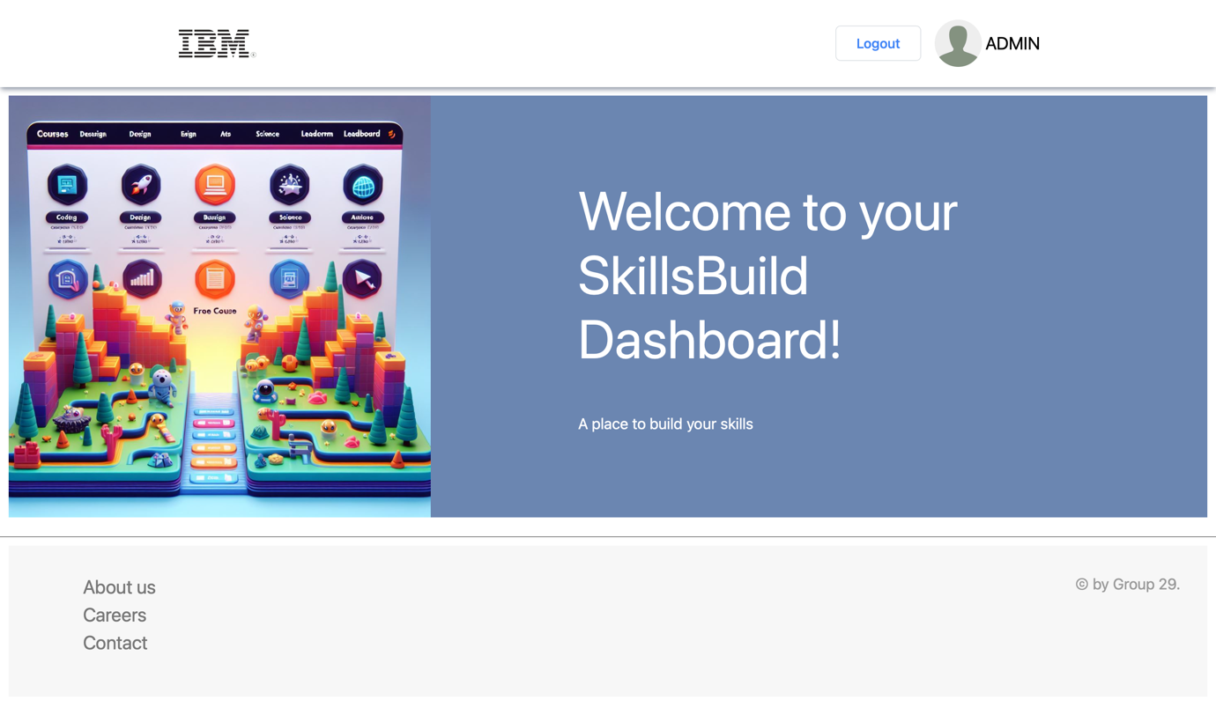

Click here to view you profile page.

As an admin, your profile ( <http://localhost:3000/admin/> ) will be set up to allow you to review and delete user comments and view data analytics including course stats.

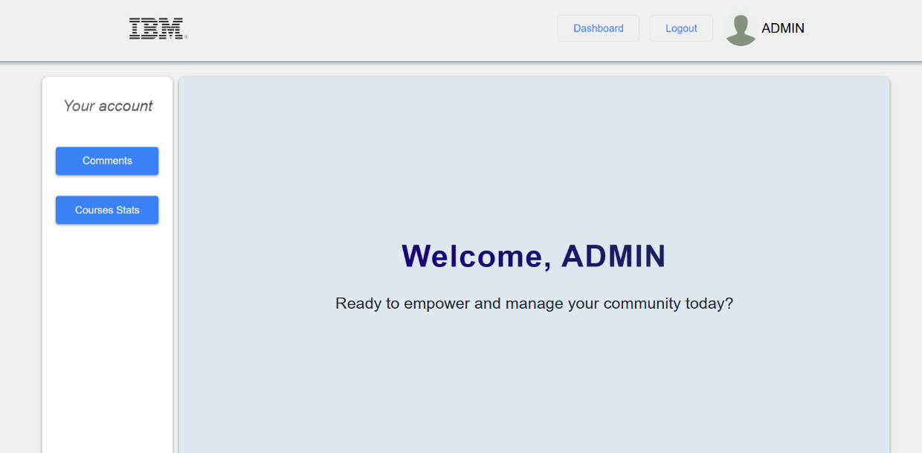

Click here to view stats about courses.

Click here to view user comments grouped by course.

Click here to view your profile.

## Admin - Deleting Reviews

<http://localhost:3000/admin/courses>

Reviews are sorted by course. To view the reviews for a specific course, click the “Check Reviews” button.

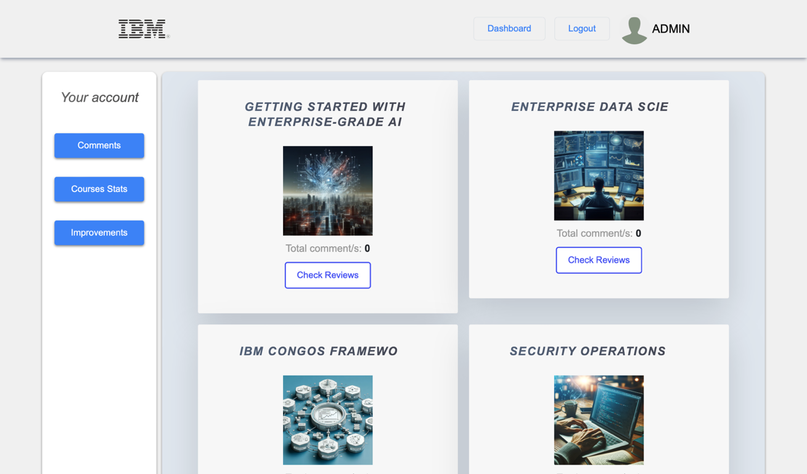

Click here to moderate reviews for a course.

You will then be directed to that course's reviews page (e.g., <http://localhost:3000/admin/getting-started-with-ai>). From here you will then be able to delete any reviews of your choice using the “Delete” button.

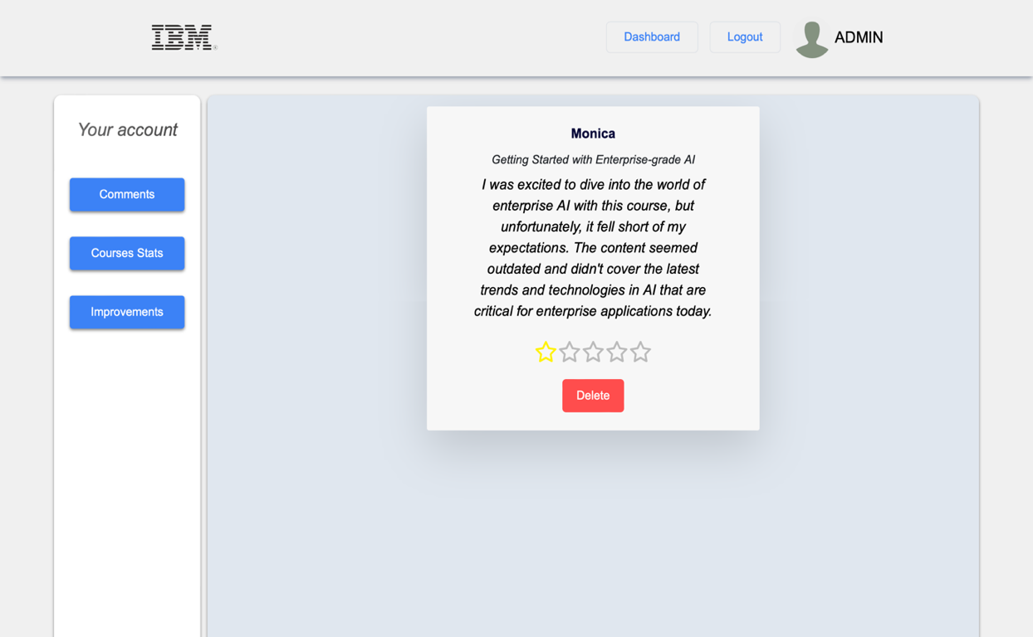

Click here to delete a comment.

## Admin Analytics

<http://localhost:3000/admin/stats>

You can view the stats for each course separately. To view them, click on the “Check Statistics” button.

You will be directed to the stats page for that course (e.g., <http://localhost:3000/admin/stats/enterprise-data-science-in-practice>). Stats for each course include the number of students enrolled on the course, the number of students who have started and finished the course, as well as the average rating and number of ratings the course has.

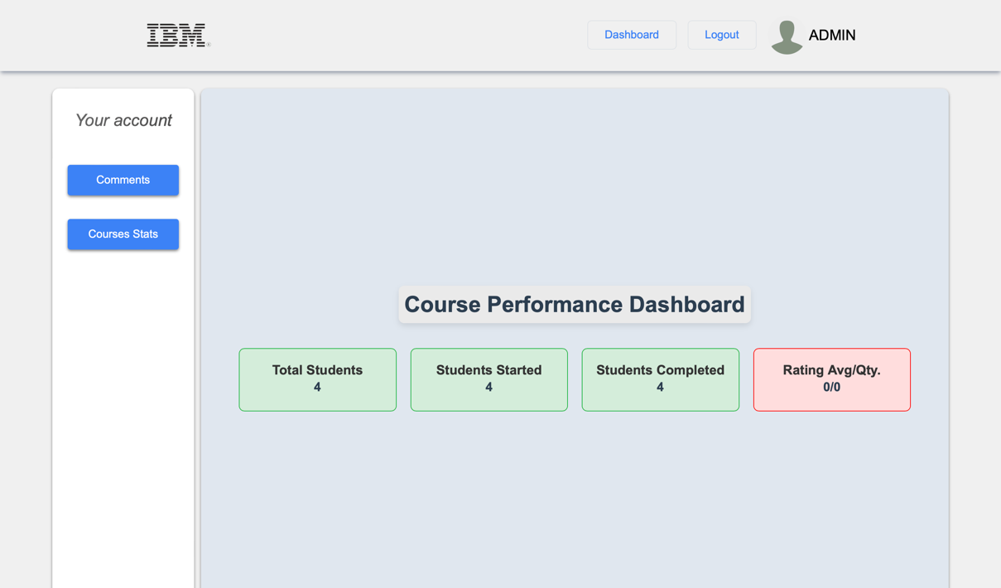

# Common errors and solutions

## Incorrect email or password

<http://localhost:3000/login>

When the user inputs an incorrect email and password an error is presented. Try to check for spelling error or type again the password or email.

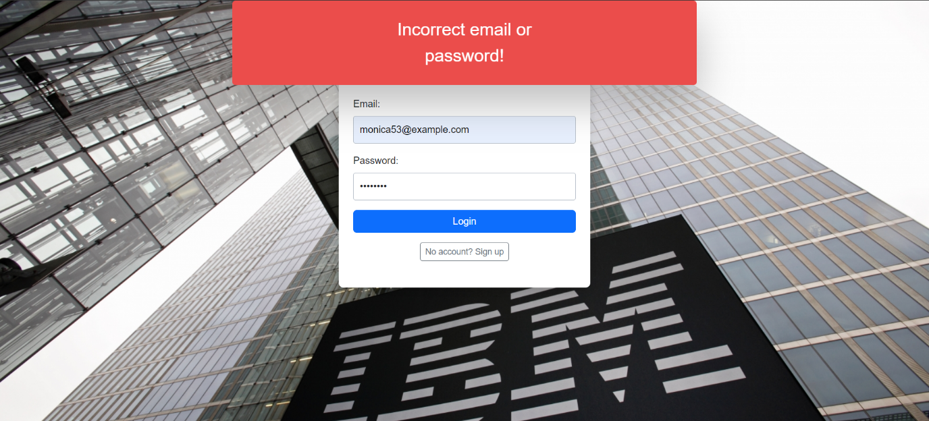

## Email already in use

<http://localhost:3000/signup>

When the user tries to register with an email address that is already in use it presents an error. If you are already registered use the log in form to log in. If it is you first time, try using another email that has not been associated with an account.

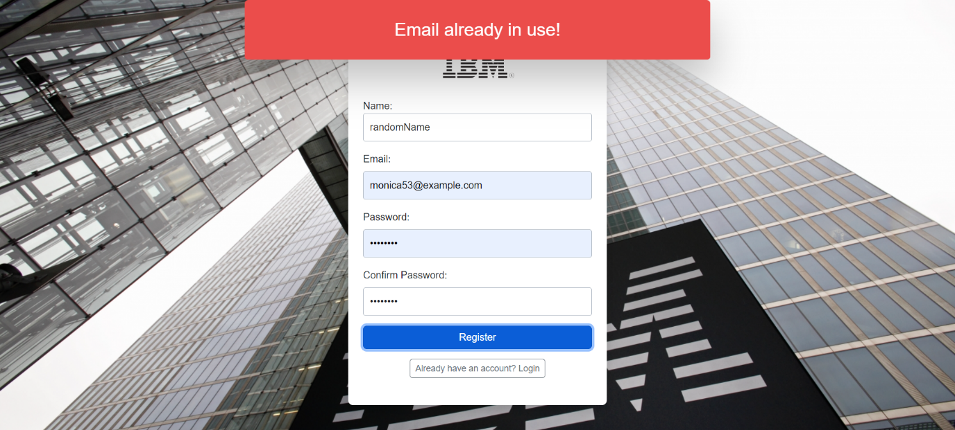

## Password does not match and the length is less than 8 characters

On the <http://localhost:3000/signup> page, if the user is to input different text in the “Password” and “Confirm Password” fields an error message is presented. If your are seeing this error, try to type the password again or check for spelling mistakes.

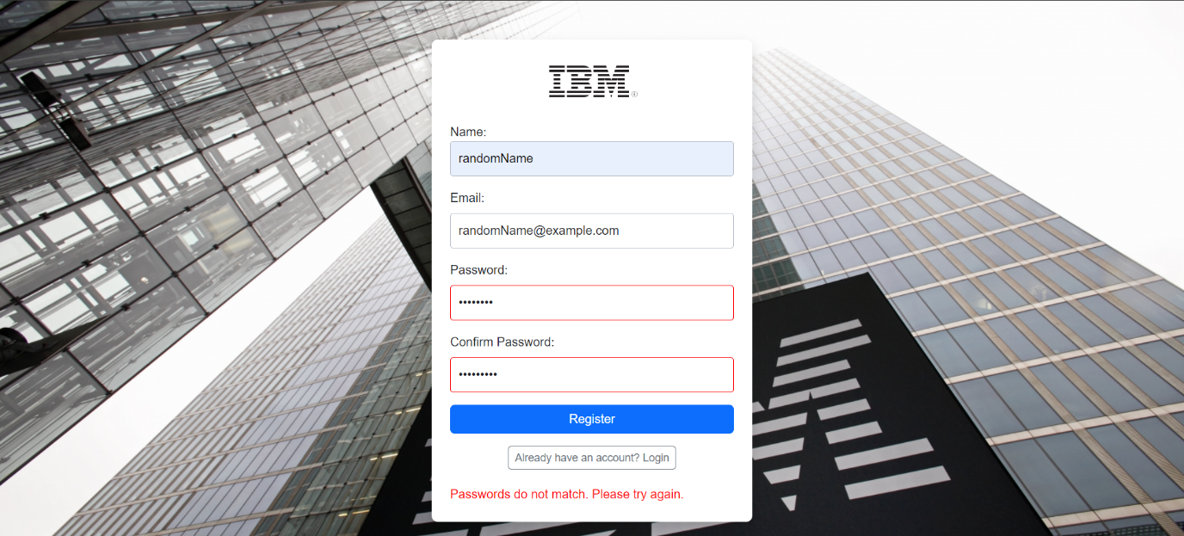

The final error handling on the <http://localhost:3000/signup> page is presented when a user tries to register with a password that is less than 8 characters long.

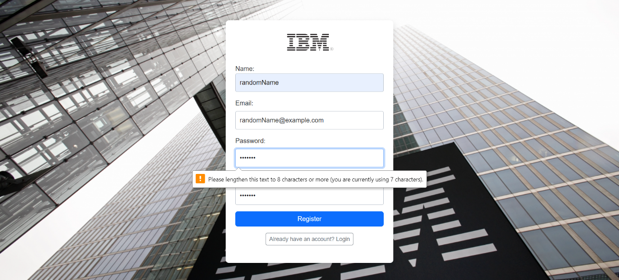

## Invalid token

<http://localhost:3000/dashboard>

When a user that is not logged in attempts to access the dashboard page an error is presented. To resolve this you must login first using this route: [IBM | Log into your account](http://localhost:3000/login)

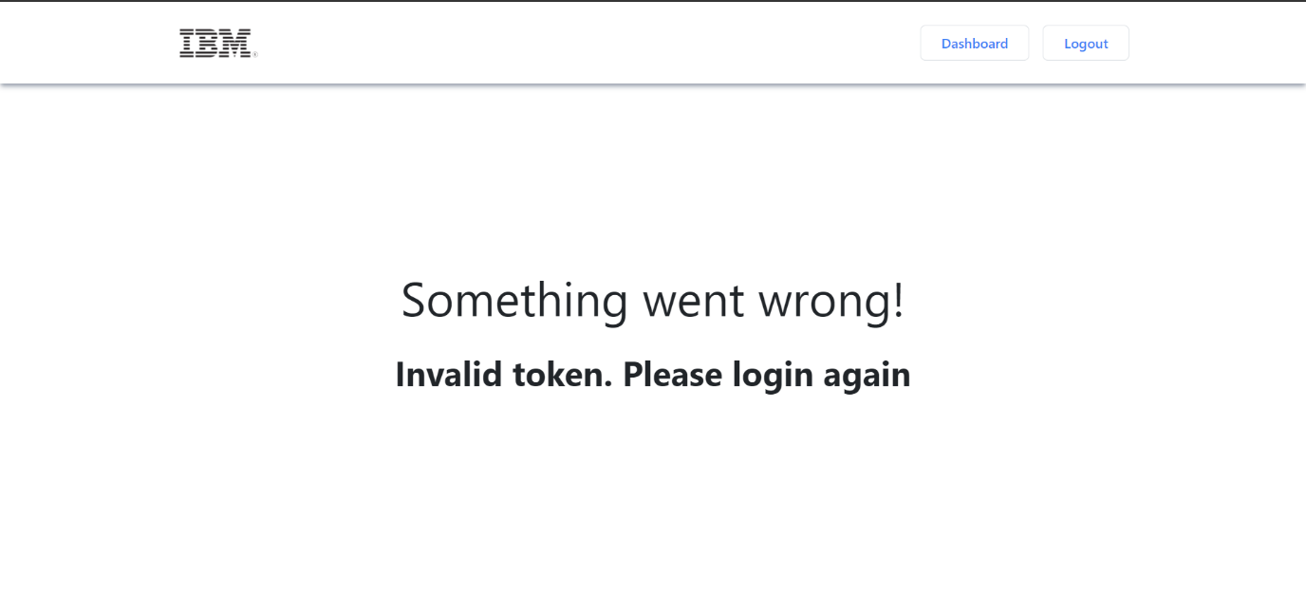

On the <http://localhost:3000/dashboard> site, if a user who is not logged in attempts to log out, they are also presented with an error message.

